|  |  |
| --- | --- |
| *Pacific Gas and Electric Company* | |
| Release 9.7.4 Installation Guide | |
|  |  |
|  |  |
| Project | ED AM/GIS |
|  |  |
| Prepared by | P1Pc@pge.com |
| Date | 9/9/2015 |
| Version | 1.0 |
| Version Type | Draft |

|  |  |  |  |
| --- | --- | --- | --- |
| Revision History | | | |
| Document # | Date | Author | Summary of Changes |
| 1.0 | 9/2/2015 | Philip Penn | Initial Document Creation |
|  |  |  |  |

# Introduction

## Purpose

This document is intended to detail the implementation and configuration steps required to implement Release 9.7.4 Installation Guide. This document describes the various configuration aspects required to complete any manual or automatic patch associated with this release. Each section in this document contains the steps required to patch the system in production.

## Terms Used

|  |  |
| --- | --- |
| OOTB | Out of the box. Unmodified from the commercial version. |
| TFS | Team Foundation Server |

## External Documents

Referenced are any external configuration documents or exports. These are documents that contain more detailed information about configuring a system or documents that can be loaded into an application to perform the configuration detailed in this document.

1. Supporting documentation folder
   1. **TFS documentation location:**

$/EDAMGIS/Source_Development_10_2_1/Documentation/Data Model/Release Documentation/EDER/9.7.4

## List of Fixes

Below is the list of change requests detailing all fixes for the data model for this release:

|  |  |
| --- | --- |
| **Item Number** | **Title** |
| [23611](http://edappgistfsprd1:8080/tfs/ElectricDistCollection/EDAMGIS/_workitems#_a=edit&id=23365) | Master TFS DM 9.7.4 |
| [23610](http://edappgistfsprd1:8080/tfs/ElectricDistCollection/EDAMGIS/_workitems#_a=edit&id=23363) | Create EDGIS.ZPGEVW_TRANSFORMER_NONOH in EDER Maintenance/Publication |
| [23691](http://edappgistfsprd1:8080/tfs/ElectricDistCollection/EDAMGIS/_workitems/edit/23691) | Update to Field Properties for Device Group type Network - Field Order for PositionDescription |
| [23696](http://edappgistfsprd1:8080/tfs/ElectricDistCollection/EDAMGIS/_workitems/edit/23696) | Update to Field Properties for CircuitSource - Allow null values to NetworkGroupName |
| [23744](http://edappgistfsprd1:8080/tfs/ElectricDistCollection/EDAMGIS/_workitems#_a=edit&id=23744) | Updates to 50 scale annotation features |
| [23780](http://edappgistfsprd1:8080/tfs/web/wi.aspx?pcguid=15e9a9d1-95cb-4dd0-abfe-5af14ae6201f&id=23780) | Modify Job Anno Class Expression on StepDownAnno/50Anno |

Contents

1 Introduction 3

1.1 Purpose 3

1.2 Terms Used 3

1.3 External Documents 3

1.4 List of Fixes 4

2 EDGIS 6

2.1 23610: Create EDGIS.ZPGEVW_TRANSFORMER_NONOH in EDER Maintenance/Publication 6

2.2 23691: Update to Field Properties for Device Group type Network - Field Order for PositionDescription 7

2.3 23696: Update to Field Properties for CircuitSource - Allow null values to NetworkGroupName 9

2.4 23744: Updates 50 scale annotation features 10

2.4.1 Remove the Horizontal Alignment AU from 50 scale annos 10

2.4.2 Configure Rotate Tool 11

2.4.3 Remove SQL Query from annotation classes 12

2.4.4 Update Maplex checkboxes 13

2.5 Update Data Model Version Table 14

3 Known Issues 15

# EDGIS

## 23610: Create EDGIS.ZPGEVW_TRANSFORMER_NONOH in EDER Maintenance/Publication

1. Open a command prompt and execute the below SQL script with the following command on the target database:  
   sqlplus edgis/<edgispassword>@<targetdatabase> @create_zpgevw_transformer_nonoh.sql  
     
   Link to SQL script: [http://edappgistfsprd1:8080/tfs/ElectricDistCollection/EDAMGIS/_versionControl#path=%24%2FEDAMGIS%2FSource_Development_10_2_1%2FDocumentation%2FData+Model%2FRelease+Documentation%2FEDER%2F9.7.4%2Fcreate_zpgevw_transformer_nonoh.sql&_a=contents](http://edappgistfsprd1:8080/tfs/ElectricDistCollection/EDAMGIS/_versionControl%23path=%24%2FEDAMGIS%2FSource_Development_10_2_1%2FDocumentation%2FData+Model%2FRelease+Documentation%2FEDER%2F9.7.4%2Fcreate_zpgevw_transformer_nonoh.sql&_a=contents)
2. Copy the output to a log file, name it “create_zpgevw_transformer_nonoh.log” and attach it to the TFS ticket for this request.

## 23691: Update to Field Properties for Device Group type Network - Field Order for PositionDescription

1. Open Arccatalog with EDGIS user.
2. Navigate to EDGIS.ElectricDataset🡪EDGIS.DeviceGroup
3. Right click on it. Select “ArcFM Properties Manager”.
4. In “Field Display” tab, select POSITIONDESCRIPTION field.

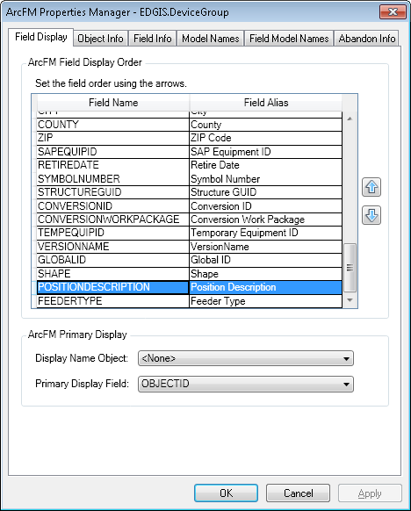

1. Click “Up” [or Down] arrow button to set the field order of POSITIONDESCRIPTION field to just below DEVICEGROUPNAME.

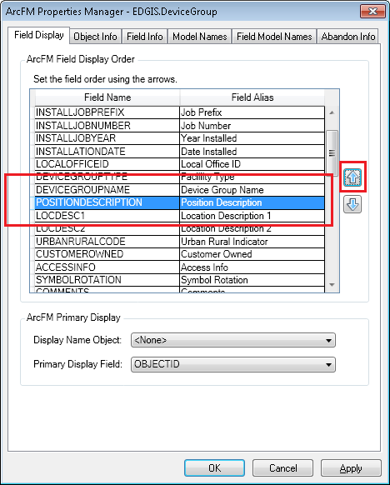

1. Click Apply. Click OK.

## 23696: Update to Field Properties for CircuitSource - Allow null values to NetworkGroupName

1. Open Arccatalog with EDGIS user.
2. Navigate to EDGIS.CircuitSource
3. Right click on it. Select “ArcFM Properties Manager”.
4. In “Field Info” tab, select NETWORKGROUPNAME field.
5. Set “Allow NULL Values” property to “Yes”.

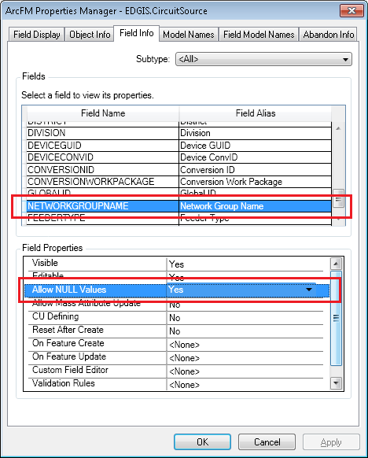

1. Click Apply. Click OK.

## 23744: Updates 50 scale annotation features

### Remove the Horizontal Alignment AU from 50 scale annos

1. Right-click on CapacitorBank50Anno and select ArcFM Properties Manager
2. Select the Object Info tab
3. In the On Feature Create event, remove the PGE Annotation Horizontal Alignment AU
4. Click OK

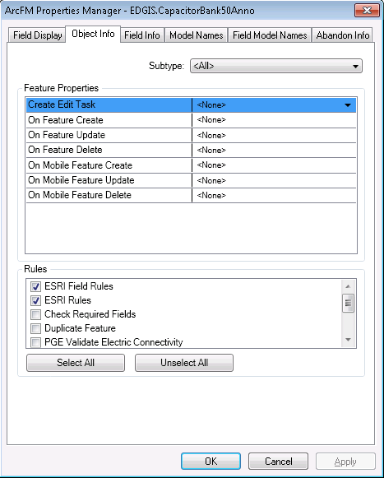

1. Repeat steps 1-4 for the following feature classes:

* DcRectifier50Anno
* DeliveryPoint50Anno
* DeviceGroup50Anno
* DynProtDevice50Anno
* FaultIndicator50Anno
* Fuse50Anno
* JobNumber50Anno
* NetworkProtector50Anno
* PrimaryGeneration50Anno
* StreetLight50Anno
* StepDown50Anno
* Substation50Anno
* SupportStructure50Anno
* Switch50Anno
* Transformer50Anno
* VoltageRegulator50Anno

### Configure Rotate Tool

1. Right-click on CapacitorBank50Anno and select ArcFM Properties Manager
2. Select the Object Info tab
3. Select the On Feature Update event and assign the PGE Preserve Anno Angle AU
4. Click OK

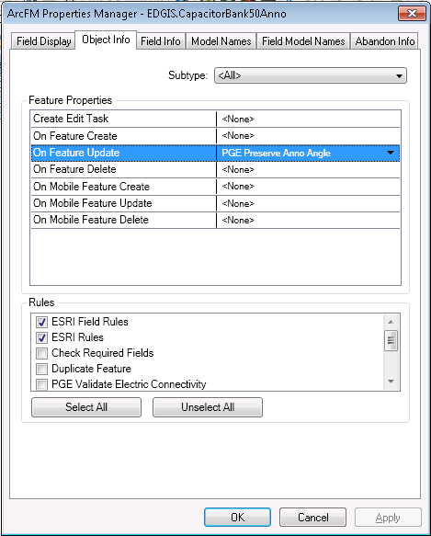

1. Repeat steps 6-9 for the following feature classes

* DeliveryPoint50Anno
* DeviceGroup50Anno
* DynProtDevice50Anno
* FaultIndicator50Anno
* Fuse50Anno
* JobNumber50Anno
* PrimaryGeneration50Anno
* SecondaryGeneration50Anno
* StepDown50Anno
* StreetLight50Anno
* Substation50Anno
* SubsurfaceStructure50Anno
* SupportStructure50Anno
* Switch50Anno
* Transformer50Anno
* VoltageRegulator50Anno

### Remove SQL Query from annotation classes

1. Right click on the StepDown50Anno feature class and select Properties
2. Go to the Annotation Classes tab
3. Select the Job annotation class
4. Click on the SQL Query button
5. Click on the Clear button to remove the expression
6. Click OK
7. Click OK

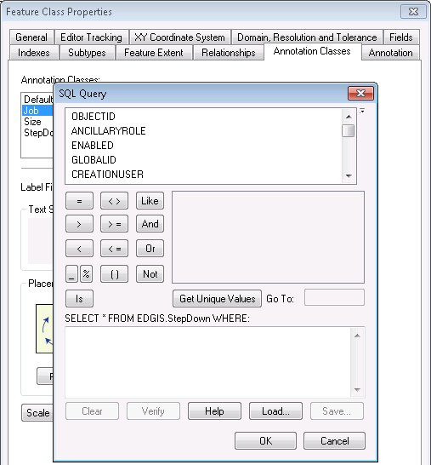

1. Repeat steps 11-17 for the StepDownAnno feature classes

### Update Maplex checkboxes

1. Right click on the DCRectifier50Anno feature class and select Properties
2. Select the Annotation Classes tab
3. Select the Default annotation class
4. Click the Expression button
5. Click on the Maplex tab
6. Uncheck the Remove extra spaces from label checkbox

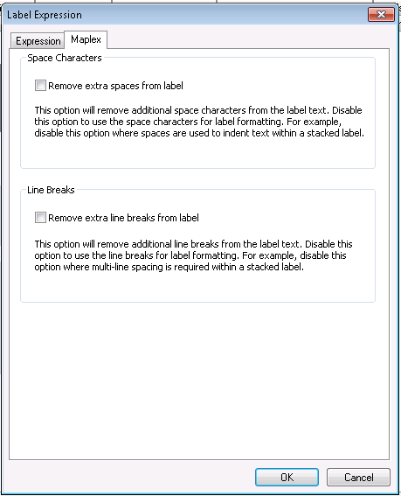

1. Click OK
2. Repeat steps 21-25 for the Job and RectNum annotation classes
3. Click OK

### 23780 Modify Job Anno Class Expression on StepDownAnno/50Anno

1. Double click on the StepDownAnno feature class.
2. In the Annotation Classes tab, select the Job annotation class.
3. Select ‘Expression’.  
   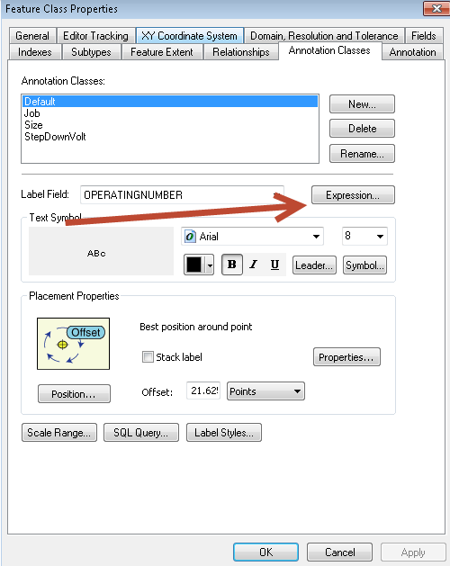
4. Clear out the current expression and paste the following code in: 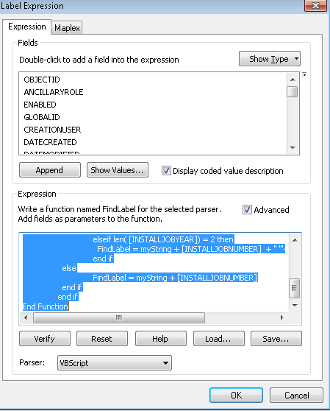

Function FindLabel ( [INSTALLJOBPREFIX], [INSTALLJOBNUMBER], [INSTALLJOBYEAR] )

if isNull( [INSTALLJOBNUMBER] ) or [INSTALLJOBNUMBER] = "0" or _

instr(ucase( [INSTALLJOBNUMBER] ), "CEDSA") then

else

if left(ucase( [INSTALLJOBPREFIX]), 3 ) <> "UNK" and _

ucase( [INSTALLJOBPREFIX]) <> "FIF" and _

len( [INSTALLJOBPREFIX]) > 0 then

myString = [INSTALLJOBPREFIX]

end if

if len( [INSTALLJOBYEAR]) > 0 then

if len( [INSTALLJOBYEAR]) = 4 then

FindLabel = myString + [INSTALLJOBNUMBER] + " '"+ right( [INSTALLJOBYEAR],2)

elseif len( [INSTALLJOBYEAR]) = 2 then

FindLabel = myString + [INSTALLJOBNUMBER] + " '"+ [INSTALLJOBYEAR]

end if

else

FindLabel = myString + [INSTALLJOBNUMBER]

end if

end if

End Function

1. Select OK and OK again.
2. Repeat the above steps for StepDown50Anno.

## Update Data Model Version Table

**Database Configuration:**

1. Open SQL Plus.
2. Log in using the same server and user as was used in section 2.1.  
     
   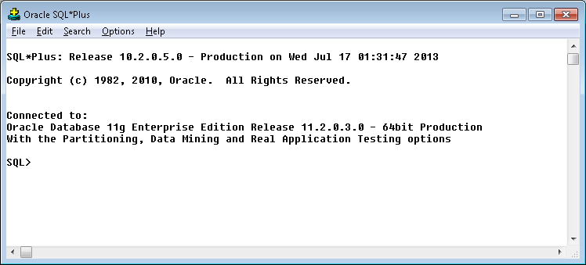
3. Run the SQL below:

update pgedatamodelversion set currentidc='N' where currentidc='Y';

insert into pgedatamodelversion (OBJECTID, CURRENTIDC, DATEAPPLIED, APPLIEDBYPERSONNAME, MODELVERSION) values (**SDE.VERSION_USER_DDL.NEXT_ROW_ID('EDGIS',(select registration_id from sde.table_registry where table_name='PGEDATAMODELVERSION'))**,'Y',sysdate,'**Philip Penn**','**9.7.4** GOLD');

commit;

# Known Issues

<Please List any other issues encountered here while following the document>